**S-Suitcase**

22/2/2020

Omniya Wahesh

Rasha Saadi

Noor Hamdan

# **Overview**

We want to use Arduino in order to make a secure suitcase.

The suitcase recognizes its owner by a facial scan (we can use espeye to do that), and we can define more than one owner for the suitcase.

The bottom of the suitcase is attached to a vacuum, that only the suitcase owners can lock and unlock, so that when the vacuum is on it would not be possible to move the suitcase. This way, we can protect our suitcase from theft or exchange with similar suitcases by mistake.

The vacuum is used for carrying heavy awkward items such as glass, doors, windows and sheet metal. It can also be used for pulling out dents from body work (see the attached video in the following link: <https://www.youtube.com/watch?v=fvAZabRmeio>). We utilize the feature “strong holding for heavy weight” in order to “lock\pin” the suitcase to the floor. In addition, the vacuum is easy to lock\unlock, and its weight is 1KG.

We have more than one plan to control the vacuum:

Plan A: to add a robotic hand that looks like “pliers” which locks and unlocks the vacuum by pushing the vacuum hand in (to lock the vacuum) and out (to unlock the vacuum).

Locking:

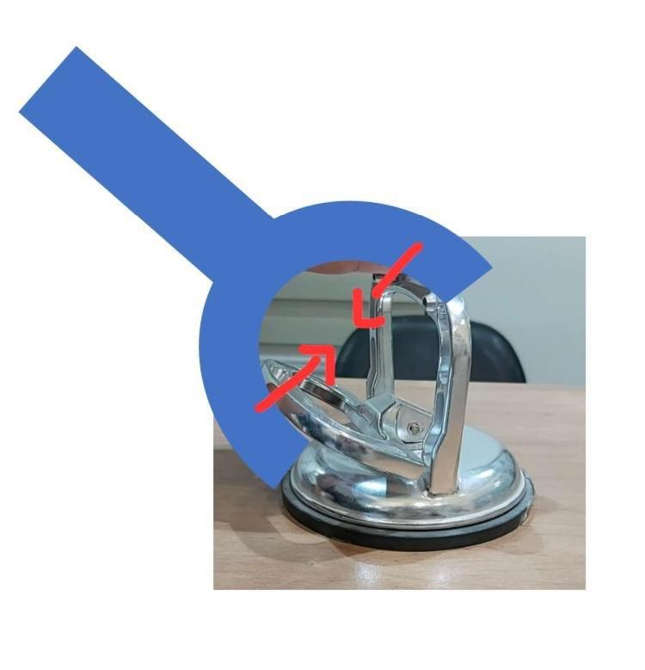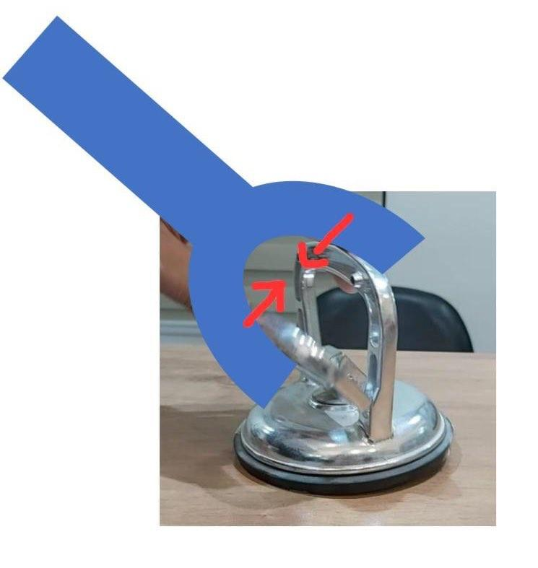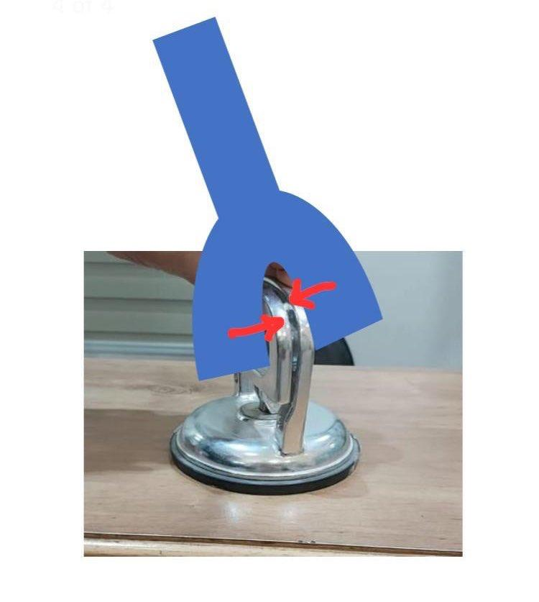

Unlocking:

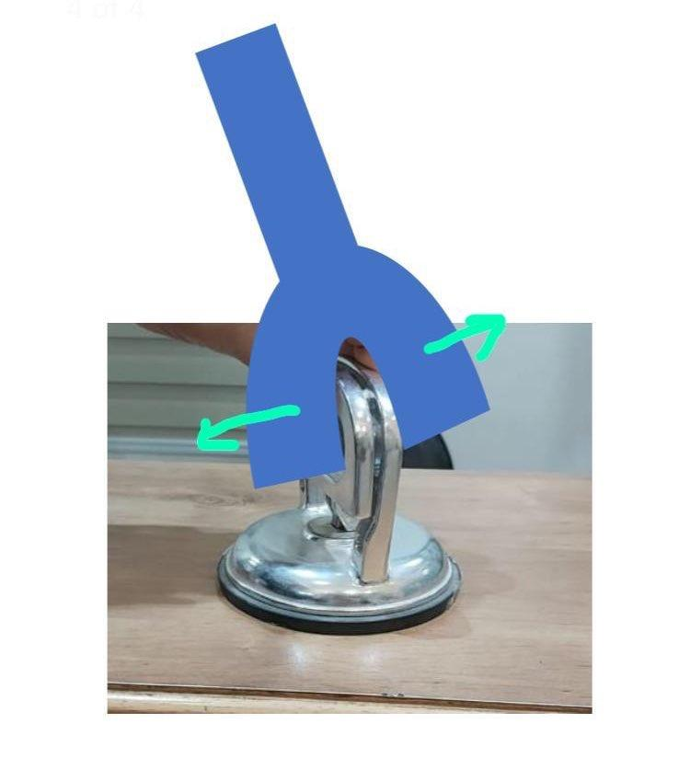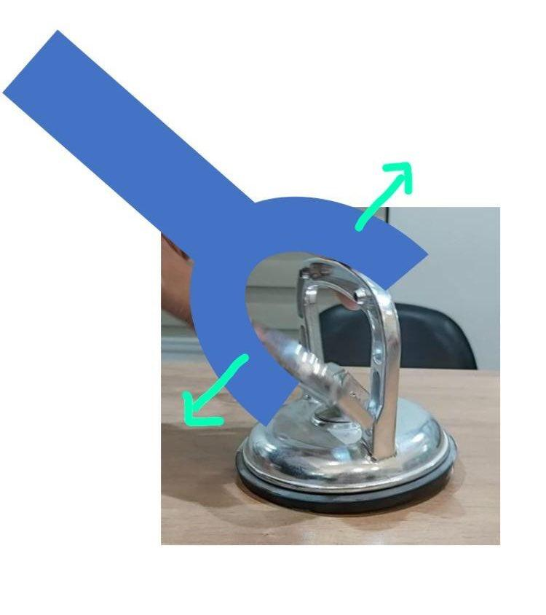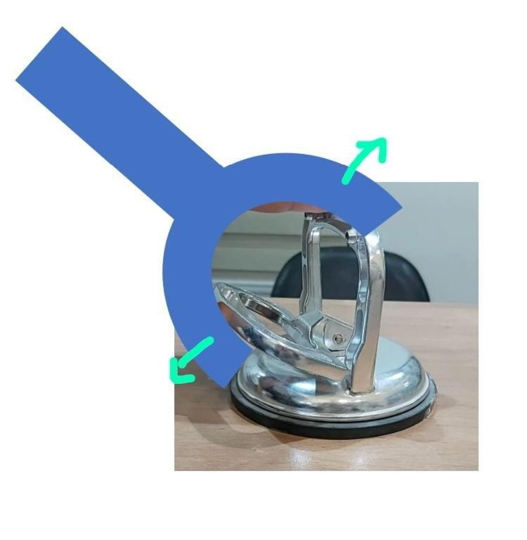

Plan B: to add a “mechanical spring” between the vacuum hands and to make a robotic hand.The robotic hand just pushes the vacuum in and keeps holding it to lock the vacuum. When we want to unlock the vacuum, we just stop holding the hand, and automatically the “mechanical spring” will push one of the vacuum’s hands to keep the hands away from each other and unlock the vacuum.

Locking: Unlocking:

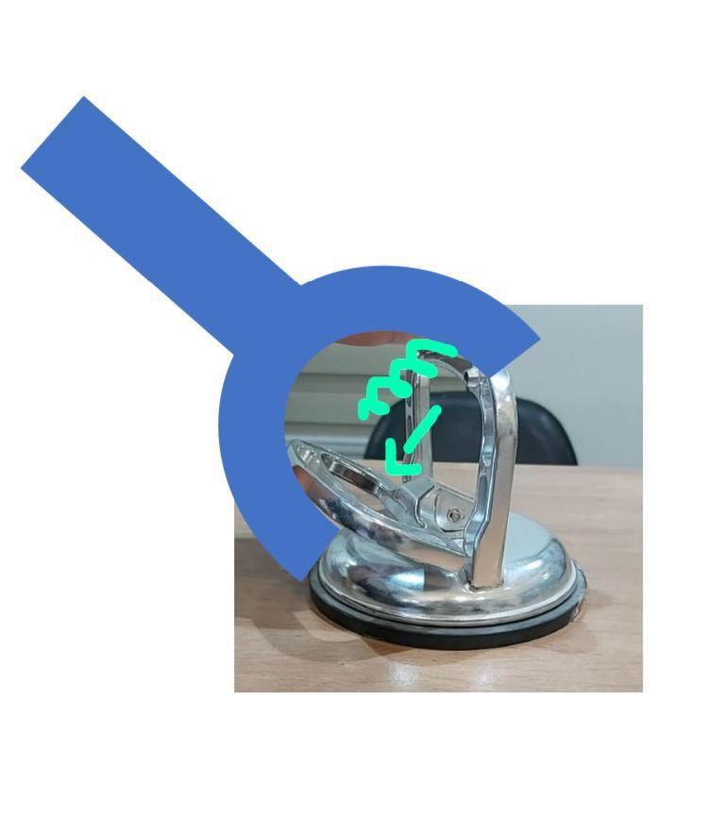

Plan C: if the two ways mentioned above can’t be implemented, then we can make a tall hand, which works the way that the “pliers” and “scissors” work. This tall hand is hidden in a secret box that the suitcase contains, and this box is opened by facial recognition (ESPEYE) and then the owner can lock and unlock the vacuum by his hands.

Moreover, the suitcase contains a GPS to help its owner know its place. The suitcase owner also can tell the application to make a sound when the suitcase is near him.

*nice to have: follow me option - the suitcase can follow its owner when it is on the floor.

We will save the owners details in a database.

*nice to have: each owner can add a list of things that he may need in his travel.

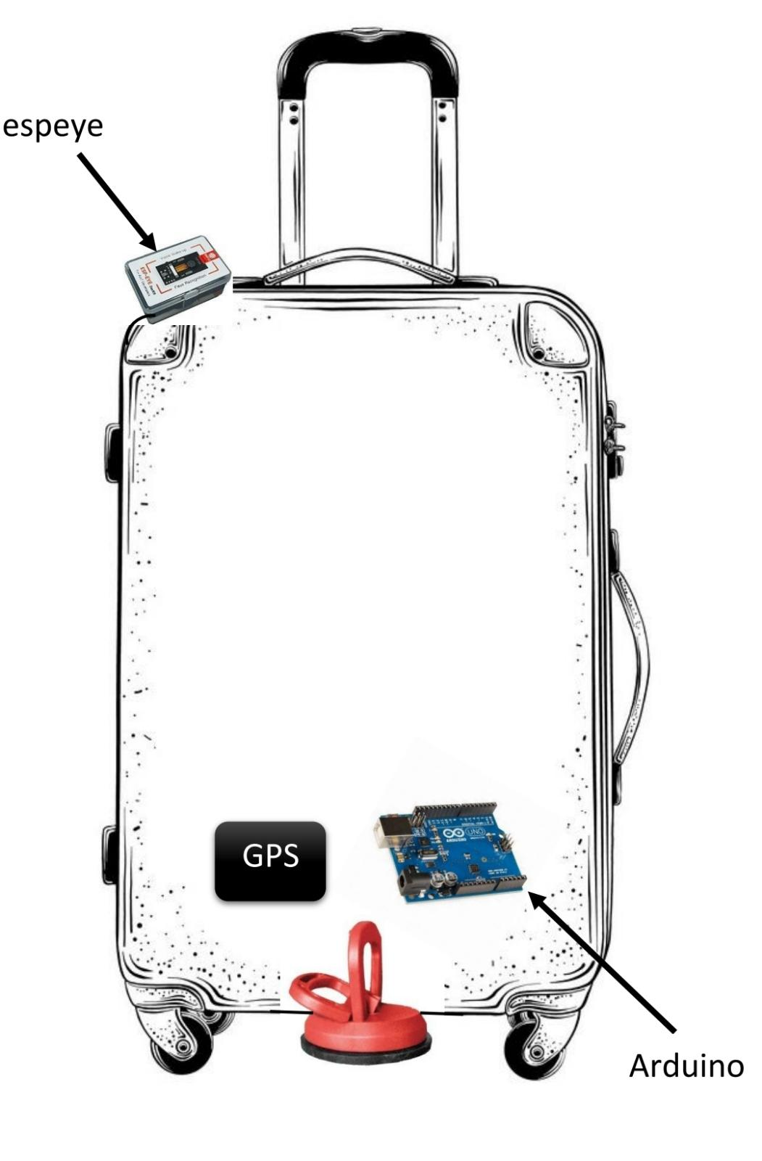

# **Interest and complexity**

1. This project helps us make our suitcases more secure - less chance to be stolen, lost or exchanged.
2. It’s a new idea. A new way to use the vacuum (usually it is used for holding up heavy stuff).
3. The project is practical: the vacuum, GPS and the espeye weight is at most 1kg, that says that the suitcase with the new features, will remain at almost the same weight.
4. We have a hardware complexity:

-to recognize the face of the suitcase owner.

-to control the vacuum correctly, how and when to lock/unlock it.

-to measure the exact distance between the owner and his suitcase (for the alarm option).

# **Difficulties during the semester**

During the semester we might encounter couple of difficulties:

1. How to hide the wheels: when we lock the vacuum the suitcase needs to get closer to the floor, and the wheels may prevent it from that.
2. How to lock\unlock the vacuum automatically: we have to design a robotic hand to open and close the vacuum automatically.
3. When we pull the suitcase we don't want the vacuum to separate from it.

**Showcase proposal**

We will present our suitcase with the new features that we added.

# **Cloud integration**

The cloud will contain a database with the details of the suitcase owners.

(*nice to have: if we have the list of the stuff that each owner needs then we will save it also in a database in the cloud).

**User-end (mobile application etc..) + optional : User Interface Flows**

We want to create an application that manages each one of the users (owners) accounts. Also, through this application we can check if the person who is trying to lock/unlock the vacuum is one of the owners. Moreover, we can use the application to know the place of the suitcase and make it alarm when our suitcase is near us.

(*nice to have: to manage also the stuff list of each user if we decided to add this feature).

**Equipment Needed**

1. Arduino.
2. Espeye.
3. GPS.
4. Vacuum (that carry greater or equal than 45 KG) <https://www.alexsander.co.il/product/8235/signet>
5. Suitcase.

**Note: our new partner details :

Name:Noor Hamdan

Email: [noor.hamdan@campus.technion.ac.il](mailto:noor.hamdan@campus.technion.ac.il)

ID:318429990